**Jumper Settings for Output Voltage Range Input Signal: 0-20mA:**

* 0-3.3V: J1 1,2 pin are short circuit connected; 3, 4 pins are short circuit connected
* 0-5V: J1 1,2 pin is a short circuit connected; 3, 4 pins are short circuit connected
* 0-10V: J1 1,2 pin are short circuit connected; 3, 4 pins are disconnected

**Jumper Settings for Output Voltage Range Input Signal: 4-20mA**

* 0-2.5V: J1 1,2 pin are short circuit connected; 3, 4 pins are short circuit connected
* 0-3.3V: J1 1,2 pin are disconnected; 3, 4 pins are disconnected
* 0-5V: J1 1,2 pin is a short circuit connected; 3, 4 pins are short circuit connected
* 0-10V: J1 1,2 pin is a short circuit connected; 3, 4 pins are disconnected

**APPLICATION**

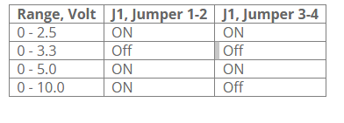

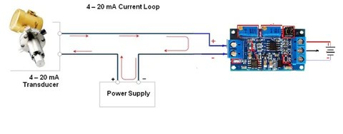

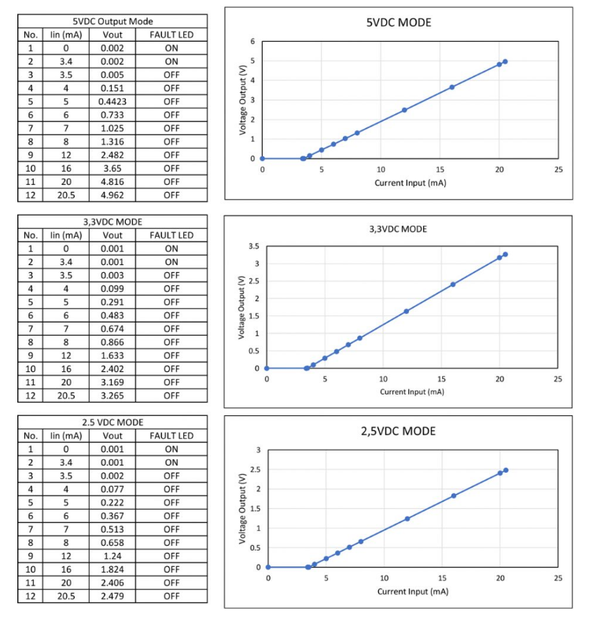

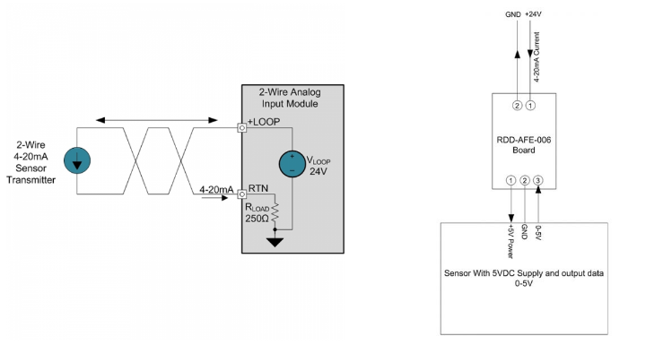

ambar . Modul *Sensor Soil Moisture*